Experiment - 2

Create a simple cloud software application for Flight Reservation System
using any Cloud Service Provider to demonstrate SaaS.

Aim: To create a simple Flight Reservation System using Zoho Creator (Cloud Service Provider) and demonstrate the Software as a Service (SaaS) model by storing and accessing reservation data through the cloud.
Procedure:
Step 1: Open a web browser and sign in to Zoho Creator using a valid Zoho account.
Step 2: Click Create New Application and choose Blank Application (From Scratch).
Step 3: Enter the application name as Flight Reservation System and click Create.
Step 4: Create a form named Passenger Details.
Step 5: Add the necessary fields to each form according to the system requirements.
Step 6: Configure appropriate field types such as text fields, date fields, dropdowns, lookup fields, and auto-number fields wherever required.
Step 7: Save the forms and allow Zoho Creator to generate reports automatically.
Step 8: Enter sample records into the application.
Step 9: Verify that the entered information is stored and displayed correctly in the generated reports.
Step 10: Access the application through a web browser to confirm that it is available online as a cloud-based application.
Output:
PASSANGER DETAILS:
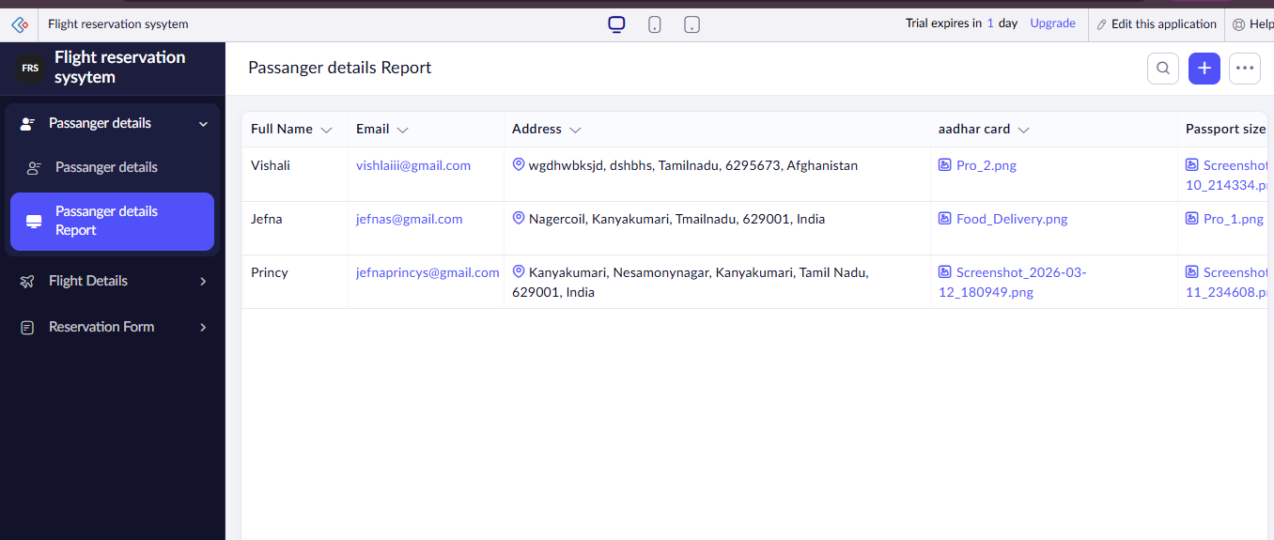

FLIGHT DETAILS:
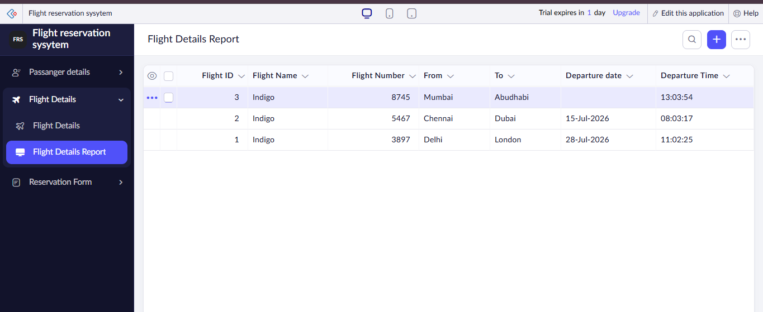

RESERVATION FORM:
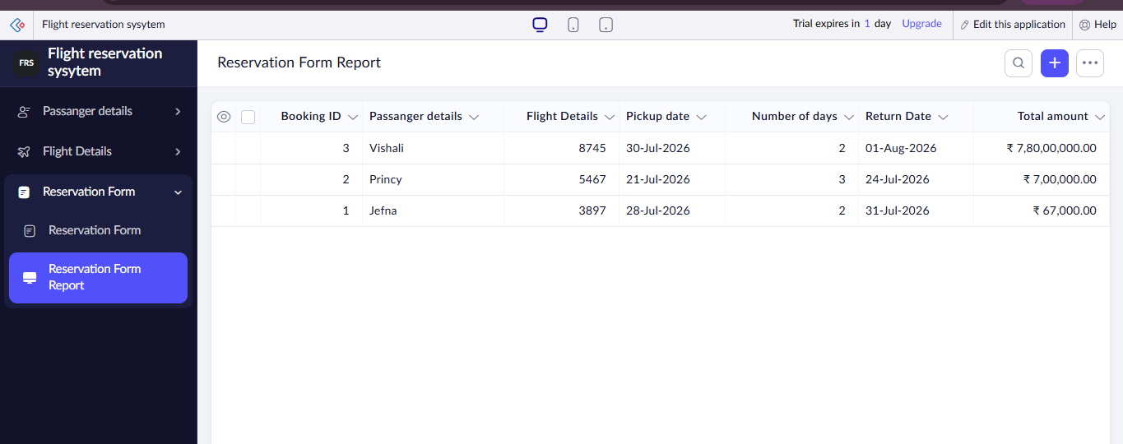

Result: Thus, a simple Flight Reservation System was successfully created using Zoho Creator, and the application was provided as a Software as a Service (SaaS) through the cloud.

